1. **System requirements**

The code has been tested on IDL (version 7.1) and Windows 10 Pro (version 20H2)

1. **Installation guide**

Install IDL as manufacturer indicates（https://www.l3harrisgeospatial.com/Software-Technology/IDL）.

1. **User guide**
2. Build project

1）Find IDL workspace folder after starting IDL, copy XtCaImagingAnalyzer there；

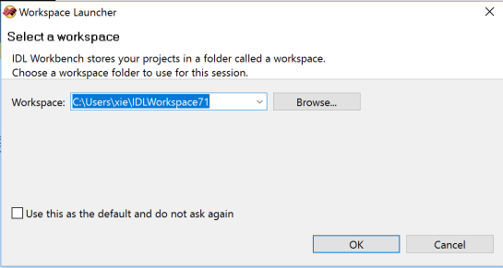

1. Start IDL，click file->new->IDL project, fill in XtCaImagingAnalyzer，click finish

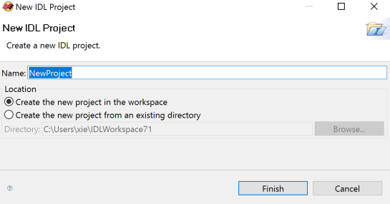

1. Compile：Click Project->Build Project
2. Run XtCaImagingAnalyzer project

Click Run->Run project XtCaImagingAnalyzer, select（Ca transients）、analysis mode (manual)、Channel（488nm），click “Execute Data Analysis”，select the file to be analyzed，click open

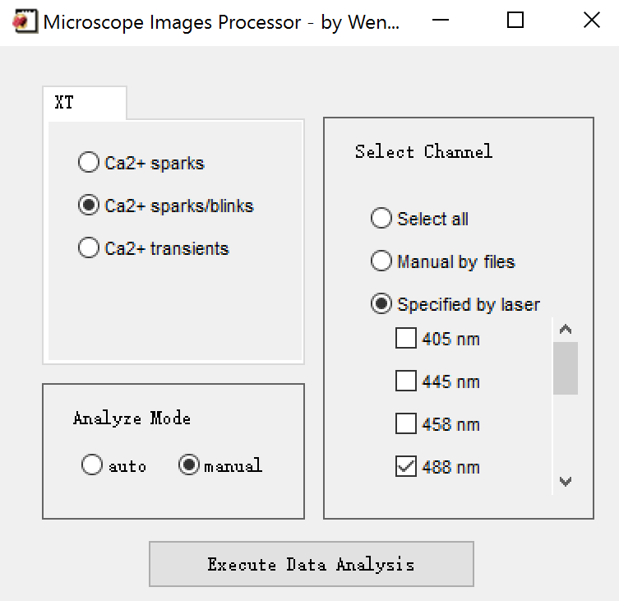



1. Analyze

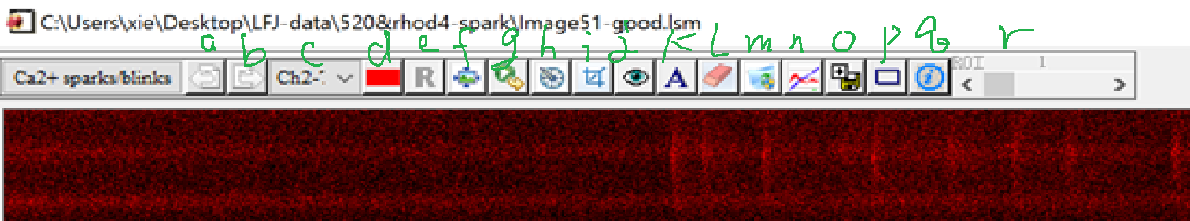

a/b ，for multiple files, select next or previous one



c C:\Users\ZY\AppData\Local\Microsoft\Windows\INetCache\Content.Word\c.png，current channel

d color mode

e regular image or normalized image

f fit image to the window

h C:\Users\ZY\AppData\Local\Microsoft\Windows\INetCache\Content.Word\h.png，set parameters as below or self-define，

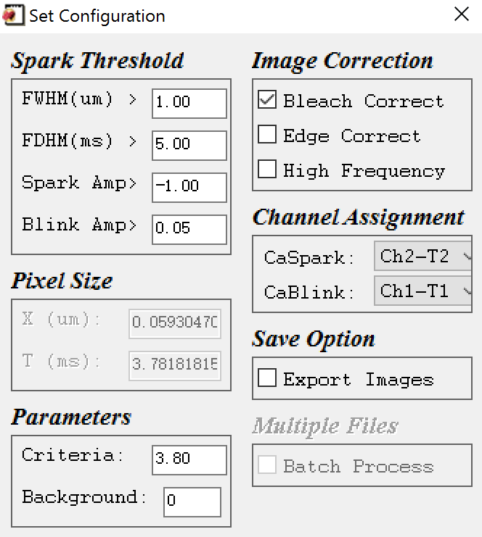

i crop region

g C:\Users\ZY\AppData\Local\Microsoft\Windows\INetCache\Content.Word\g.png，execute the analysis

1. **Output**

**spark_para.txt**, **file name、signal mass**